**Assignemnt 3A**

**Index.html**

const http = require('http');

const url = require('url');

const fs = require('fs');

const path = require('path');

const PORT = 1800;

const mimeType = {

'.ico': 'image/x-icon',

'.html': 'text/html',

'.js': 'text/javascript',

'.json': 'application/json',

'.css': 'text/css',

'.png': 'image/png',

'.jpg': 'image/jpeg',

'.wav': 'audio/wav',

'.mp3': 'audio/mpeg',

'.svg': 'image/svg+xml',

'.pdf': 'application/pdf',

'.doc': 'application/msword',

'.eot': 'application/vnd.ms-fontobject',

'.ttf': 'application/font-sfnt'

};

http.createServer((req, res) => {

const parsedUrl = url.parse(req.url);

if (parsedUrl.pathname === '/') {

var filesList = fs.readdirSync("./public/");

var filesLink = "<ul>";

filesList.forEach(element => {

if (fs.statSync("./public/" + element).isFile()) {

filesLink += `<li><a href='./${element}'>${element}</a></li>`;

}

});

filesLink += "</ul>";

var html = `

<!DOCTYPE html>

<html>

<head>

<meta charset="UTF-8">

<title>Directory Listing</title>

<style>

body {

font-family: Arial, Helvetica, sans-serif;

background-color: #f4f4ff;

width:50%;

margin:0 auto;

}

h1 {

text-align: center;

color: #555;

margin-top:5rem;

}

ul {

list-style: none;

padding: 0;

margin: 0;

}

li {

margin-bottom: 10px;

background-color: #fff;

padding: 1rem ;

border-radius: 5px;

width: 55%;

margin: 1rem auto;

}

a {

text-decoration: none;

font-weight: bold;

color:#5555ee;

font-size:1.2rem;

}

a:hover {

text-decoration: underline;

}

</style>

</head>

<body>

<h1>Welcome To My Web Server <br></h1>

<h2 style="text-align: center"> We have following Public files to share</h2>

<hr>

${filesLink}

</body>

</html>

`;

res.setHeader('Content-type', 'text/html');

res.end(html);

} else {

const sanitizePath = path.normalize(parsedUrl.pathname).replace(/^(\.\.[\/\\])+/, '');

let pathname = path.join(__dirname + "/public", sanitizePath);

if (!fs.existsSync(pathname)) {

res.statusCode = 404;

res.end(`File ${pathname} not found!`);

} else {

fs.readFile(pathname, function (err, data) {

if (err) {

res.statusCode = 500;

res.end(`Error in getting the file.`);

} else {

const ext = path.parse(pathname).ext;

res.setHeader('Content-type', mimeType[ext] || 'text/plain');

res.end(data);

}

});

}

}

}).listen(PORT);

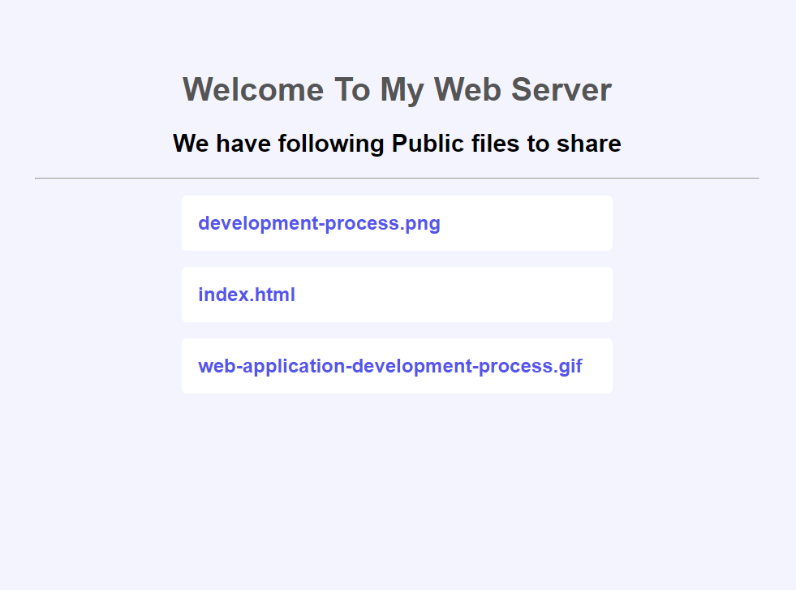**output:**

